CALIFORNIA COASTAL COMMISSION First sent 2/16/17
Attn: Enforcement Officer Andrew Willis - Amended March 5, 2017

REQUEST TO MEET AND HAVE RESPONSE TO QUERIES REGARDING THE PLAYA VISTA CDP(S) --
- their fulfillment and/or lack of fulfillment & subsequent consequences and,
- CCC SA, CDP(s) --current impacts upon Ballona’s restoration alternatives.

As we have previously discussed, the plan for the “restoration” of Ballona Wetlands has been heavily influenced and controlled by Playa Vista’s development history. The Settlement Agreement between the California Coastal Commission, Playa Vista and Friends of Ballona included factual misstatements that created a pre-determined outcome for ‘restoration’ proposals. Most specifically, the CCC’s Settlement Agreement Language arising out the Friends of Ballona lawsuit appears to have included language for “restoration of Ballona” to create an “embayment” and restore the “ebb and flow of the Ocean” to Ballona as a salt marsh. Such language was also inserted into the CDP’s for Playa Vista.
Unbeknownst to the public at large, was that this Settlement Agreement included the California Coastal Commission, LA County, City of LA, the State Lands Commission & the State Controller’s Office, Playa Vista, Friends of Ballona who were all divvy up the land uses of the immediate area and who all agreed that in order to do this, and save a small portion of Ballona Wetlands-- that they would agree to fast tracking the slightly altered Playa Vista development project. All parties became legally bound to a predetermined outcome, set forth in the SA.
None of this information was relayed to the public at large and none of it was inserted into the bond language that the public approved when it voted to approve the bond money that was used for the acquisition and restoration of Ballona Wetlands Ecological Reserve in 2003-4. The bond language contradicts this predetermined outcome via citations of inclusion of ‘all reasonable alternatives’ studied for restoration and includes the transparent and complete inclusion of the public in the entire process.

Through recent historical reports including, Historical Ecology of the Ballona Creek Watershed- Travis Longcore PhD et al., paid for with public bond money earmarked for Ballona’s restoration, we now know that historically, the Ballona Wetlands was not a salt water marsh. It was a freshwater marsh that occasionally broke through to the Ocean, which allowed for some saltwater interaction. We now know that the CCC Settlement Agreement, which gave rise to the language of Playa Vista’s CDP(s) and later USACE permit language utilized incorrect historical and geological characteristics in describing the Ballona Wetlands.

This factually incorrect description made its way into EIR for the Playa Vista development project and has continued to be wrongfully applied to Ballona Wetlands ever since. More recent studies and legal challenges have proven Ballona is a rare, predominantly seasonal freshwater wetlands.

WRONGFUL PREMISE
The wrongful characterizations of Ballona as a salt marsh continue into present language used by USACE and CDFW, and the California Coastal Commission which has created an ‘agency used false premise’ upon which all ‘restoration alternatives’ are based.

Ballona Wetlands is a predominantly freshwater, seasonal wetland along our coast and has had historic saltwater influence during years of unusually heavy rainfall which broke through coastal dunes allowing for short lived tidal influence directly from Santa Monica Bay.

IMPROPER PROCESS
None of the state’s alternative planning includes restoration for Ballona as a seasonal freshwater wetland. No Ballona freshwater hydrology studies have been done as part of the restoration planning for Ballona. Only HYDRAULIC STUDIES of the Ballona Channel water flows have been prepared, which precludes any Alternatives and studies that would illuminate the preservation needs and utilization of the freshwaters of Ballona Wetlands - inclusive of runoff,

- The Playa Vista/ CDFW unpermitted drains are also a violation of the Coastal Act. They continue to illegally take away Ballona’s freshwaters both surface and subsurface. CDFW continues to fail to seek a CDP through the CCC and fails to stop the ongoing drainage.
- Playa Vista dewatering-- done for both decontamination, as well as methane gas mitigation systems-- removes virtually all historic freshwater flows into Ballona from east to west. Both surface and ground waters, that historically provide Ballona’s near surface waters, are being removed through dewatering. Such near surface waters are removed from the historical wetlands located at what is now Playa Vista via either the sanitary sewer systems to Hyperion and/or via the Playa Vista Flood Control System (aka Freshwater Marsh System) which flushes Ballona’s freshwaters out into the Santa Monica Bay using the Ballona Channel.
- The freshwater storm runoff into the Playa Vista flood control basin system, is also diverted away from Ballona Wetlands into the Ballona Channel to the sea.

No hydrology studies of Ballona Wetlands itself have been done to determine the negative impacts of the cumulative freshwater dewatering to Ballona Wetlands as can be noted in the following document portion produced by a member of the Project Management Team in the current EIR/S; Water Resource Development Act (WRDA) process. (Public Record Act response document)
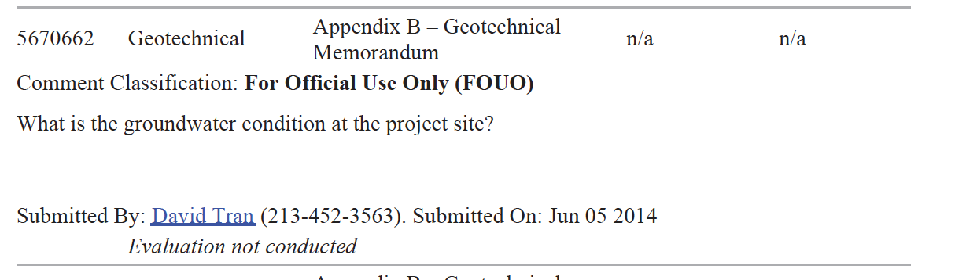

LACK OF TRANSPARENCY- MISLEADING THE PUBLIC

The overall lack of transparency and use of misleading the public into responding to
an EIR/S that would include only the wrongfully premised alternatives- industrial scale digging out of Ballona to create ‘an embayment’ as Ballona’s restoration ----is an ongoing goal promoted by conflicted interests and a corrupted process.

Examples of the pattern and practice of lack of transparency and misleading the public:
Please SEE the parking structure e-mail attachment on page 9. Such email evidences inter-agency manipulation of information to deceive the public intended to create an outcome favorable to county development interests and CDFW work issues. See also, Vector Control Letter p. 4, for lack of accountability and confusion.

CONFLICTS OF INTEREST
Multiple conflicts of interest impact decisionmaking on the Ballona Wetlands Restoration
- Due to prior agreements not disclosed to the public and/or not amended to reflect the changed circumstances of public ownership of Ballona Wetlands since 2004.
- The EIR/S Project Management Team includes Playa Vista consultants promoting the
Interests of Playa Vista. These interests date back to fulfillment of the CCC’s Settlement Agreements.
- Partnerships that have the appearance of conflict of interest, such as 1.
The Ballona Conservancy* whose origin, board members and use remains mysterious and murky, with questionable inclusion of state agencies: a. the State Lands Commission*; b. the Ca. Dept. of Fish & Wildlife*; c. the local CD 11 council district personnel and; d. developer interests - Playa Capital LLC/ Brookstone*; e. Friends of Ballona (leadership of this group are directly or indirectly related to Playa Vista). The Ballona Wetlands Conservancy was NOT a part of the Settlement Agreement which required the parties to the SA (The Committee) to create a Ballona Wetlands Foundation that would provide oversight of the Freshwater Marsh System (Playa Vista’s Flood Control System) and yet, the CCC has been accepting reports from the Ballona Wetlands Conservancy, regarding the viability of the Playa Vista Flood Control System since, at least mid-2000. The relationship between the CCC and the Ballona Wetlands Conservancy needs to be historically unravelled and explained to the public.
The leadership of the Ballona Conservancy, created by Playa Vista, ostensibly for Playa Vista, provides questionable oversight of the Playa Vista flood control system for Playa Capital LLC/Brookstone development---a money making venue that, but for its required completion under the CDP(s) and interwoven Army Corps of Engineers Permit---the development would not be allowed.

- Playa Vista/ CDFW drains in Ballona Wetlands Reserve are both unpermitted and a violation of the Coastal Act. The drains continue to illegally take away Ballona’s freshwaters both surface and subsurface.
- Playa Vista dewatering-- done for both historic toxic decontamination, as well as for keeping clear the methane gas intake systems-- removes virtually all historic freshwater flows into Ballona from east to west. Both surface and ground waters, that historically provide Ballona’s near surface waters, are being removed through dewatering. Such near surface waters are removed from the historical wetlands by Playa Vista via both the sanitary sewer systems to Hyperion and/or the Playa Vista Flood Control System (aka Freshwater Marsh System) that drains into the Santa Monica Bay via Ballona Channel. The fresh rainwater runoff that is diverted into the Playa Vista flood control system, is drained away from Ballona Wetlands to the sea.

* Number 3:

1. * The Ballona Conservancy has employed contractors that have direct links to Playa Capital. For example, it has employed Psomas, which also worked on behalf of the development of Playa Vista and its flood control needs. Psomas has been allowed by State and Federal agencies to be employed in a position of authority over Ballona’s restoration--namely as a member of the Project Management Team- - for oversight of Ballona Wetlands restoration permits currently sought from USACE through the ongoing WRDA- Water Resource Development Act processes engaging LA County, CDFW and the Santa Monica Bay Restoration Commission(SMBRC).

a. *SLC, was a part of the CCC’s SA inclusion as part of the Ballona Committee. The SLC claims it is NOT a member of the Ballona Conservancy, however it ‘owns’ the land of the freshwater marsh. SLC’s role has become ambiguous and vague and needs to be made clear to the public.

b. *CDFW is assigned the role of stewardship of Ballona Wetlands Ecological.

c….* CD 11 has apparent conflicted interests in its decision making regarding Playa Vista. Examples include but are not limited to:

1) The failure of CD11 to alert the public and the LA City Council to the multi-year warnings from Vector Control and failure to inform the public and LA City Council regarding the Vector Control threats of fines imposed upon the membership of the Ballona Conservancy for its failure to properly maintain the Playa Vista flood control system and; 2) the failure of CD 11 to alert anyone to the illegal roadway creation (2016) at Playa Vista along the riparian corridor section of Playa Vista’s flood control system. This roadway was also cited as a CDFW Stream Bed Agreement Violation; 3) CDP fulfillment needs not addressed by CD 11; 4) Playa Vista Vesting Tract Agreements regarding the Playa Vista flood control systems, not addressed for fulfillment.

d. * Playa Vista has direct interests in fulfillment of its flood control needs per its CDP(s) and its USACE permits. Its flood control needs appear to be unfulfilled at this time and tied to the
“embayment” restoration of Ballona. Playa Vista and its contractors, as part of the EIR/S Project Management Team, have—at least—the appearance of a direct conflict of interest.

e. * Friends of Ballona has had a lengthy history of friendly take-over by Playa Vista leadership.

The following is one email correspondence between LA County Vector Control and the Ballona Wetlands Conservancy via Playa Vista’s leadership figure, Marc Huffman.

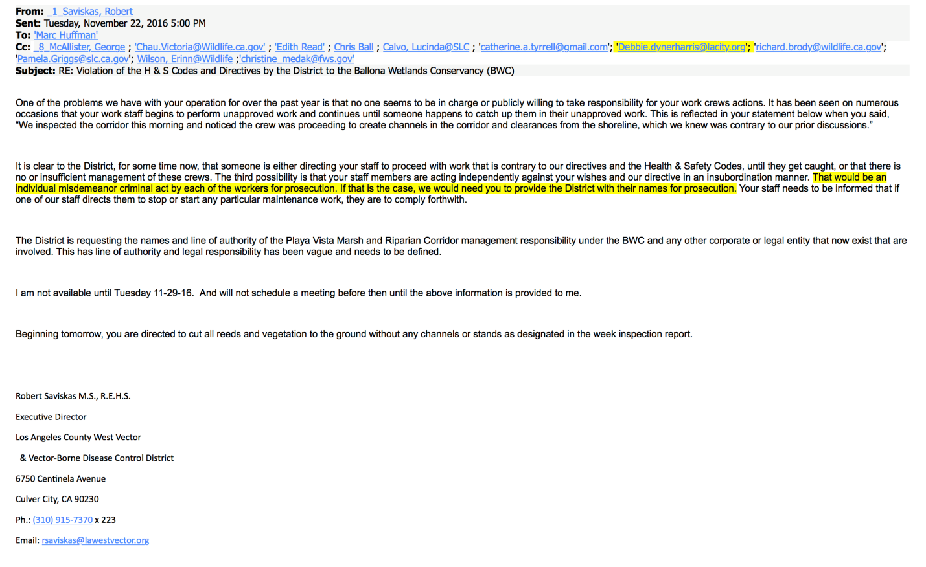

- Ballona Wetlands Landtrust v Santa Monica Bay Restoration Commission (SMBRC)

http://www.ballona.org/litigation/

Public Record Act litigation reveals in depositions from key SMBRC personnel, who are also leaders of the Santa Monica Bay Restoration Foundation (a private business overseen by numerous parties that historically and currently have financial and influential interests tied to Playa Vista and Playa Capital LLC) and, who have provided a false pretense of authority that was utilized in order to ensure agreements were reached between the LA County Flood Control District and the U.S. Army Corps of Engineers, ensuring: 1) the WRDA process would be engaged to streamline/ piecemeal the process into a permit process, while extinguishing without accountability, the formerly approved EIR/S process (2005-12) which was to review ALL REASONABLE ALTERNATIVES and, 2) a singular outcome-namely saltmarsh, either full tidal and/or muted tidal, for Ballona’s restoration would be the only alternatives studied and paid for with bond funds. (Ballona Wetlands Landtrust prevailed in the PRA litigation.)

The false representations made have secured an inaccurately premised WRDA permit process as part of a deceitfully contrived and truncated, EIS/R process that ensures that the historically correct geography and geology of Ballona Wetlands will not be a part of the WRDA Permit--EIS/R process.

Instead, the restoration alternatives under study and review, only appear to pertain to the unresolved and incomplete flood control needs of the Playa Vista development site. Namely, a digging out of Ballona to create the ‘embayment’ envisioned in the Settlement Agreement between the CCC and Friends of Ballona et al., including Playa Vista.

California Coastal Commission’s Playa Vista CDP(s)

The second CDP Application—digging out Ballona in the extended wetland parcel of the freshwater marsh system, if approved by the CCC, as Playa Vista intended, would have provided completion of the Playa Vista flood control system.
The completion of the flood control system was based upon digging out a portion of the freshwater marsh system, just south of the freshwater marsh aka the ‘extended wetland parcel’. This second CDP action is cited in the CCC approved CDP, utilizing USACE flood control permit description language. It is believed that the two coastal development permits, acting together, were intended to complete a flood control system as a two phase approach for a singular goal-- for fulfillment of a completed flood control system-- that would allow for all phases of Playa Vista’s development to either proceed and/or remain in place.

The second CDP Application, whether ever submitted to the CCC, has no recordation at the CCC of approval. However, it does appear that the second CDP action—that of digging out a portion of Ballona in the freshwater marsh system, is still necessary for fulfillment of Playa Vista’s flood control needs. Email correspondence between the SMBRFoundation, CDFW and a Playa Vista consultant appear to corroborate that the current “alternatives” that are being promoted by CDFW and the Coastal Conservancy—namely the digging out of Ballona—will fulfill the flood control needs that were never completed by Playa Vista. In other words, the digging out of the extended wetland parcel, would fulfill the USACE permit needs. Both the USACE PERMIT approval and the CCC’s CDP(s) language both cite a phased approach to the completion of the flood control system (aka freshwater marsh system) in which the dig out of the extended wetland parcel was to
occur within a reasonable time. However, to present, this development portion of the CDP and USACE Permit has not been done. It appears that the flood control system of Playa Vista remains undone.

The following 2012 email references an outlet drain being discussed while Playa Vista’s , Psomas contractor-Mike Crehan, discusses the future,
“ …the ultimate condition when the brackish marsh is developed.”
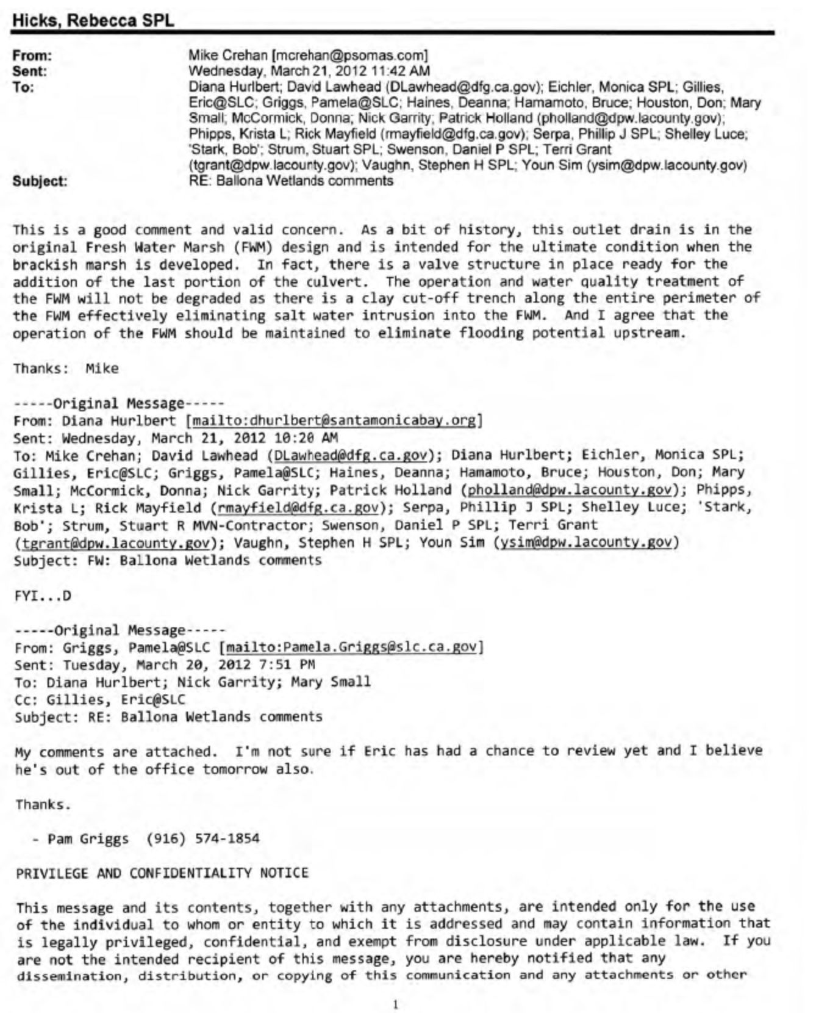

It is not incumbent upon the public, who paid for Ballona, to fulfill the flood control needs of the development project—Playa Vista.

History is again key, since it was the Settlement Agreement (SA) of the Coastal Commission that set into motion the language of the approved CDP(s) of Playa Vista which inculcated the USACE FLOOD CONTROL PERMIT description and needs.

The public’s bond money dedicated to Ballona’s restoration—Proposition 12 funds—have been overseen and disbursed by the Ca. Coastal Conservancy and have been disbursed largely to the bank accounts of the SMBRFoundation which theoretically but wrongly was citing itself as the “ fiscal agent” on behalf of the Santa Monica Bay Restoration Commission. (The relationship between the state agency-SMBRCommission and the private business- SMBRFoundation however ,was wrongly stated by SMBRFoundation leaders in their portrayal of BEING and ACTING AS the SMBRCommission. SEE Landtrust Public Record Act lawsuit for detailed misrepresentations and false statements made by SMBRFoundation leaders.

The Prop. 12 funds have virtually all been expended by the Coastal Conservancy, with much to the SMBRFoundation for studies that ONLY pertain to the digging out of Ballona, the saltwater “embayment” envisioned in the SA and CDP language.

The Coastal Conservancy lead person for Ballona Wetlands was a board member of the SMBRFOUNDATION at the time that alternative decisions for Ballona were being made by the Coastal Conservancy.
The SMBRFOUNDATION has been an entity created by a Playa Vista consultant, a creator of the Playa Vista flood control system, whose history reveals its dedication to the goal of a saltwater ‘embayment’ and whose board members misrepresented themselves as acting as SMBRC leadership, in order to further the USACE, WRDA –streamlined permit process toward that goal.

The very serious implications of a process gone awry with conflict of interest and false representation, needs to be openly and publicly vetted. The CCC’s role in the history of Ballona, though one of good intent, needs to be reviewed in light of how its CDP(s) are currently affecting Ballona’s restoration.

Attachments per comments on Page 2:
This parking structure was never made public during any scoping process and was instead concealed

Continued page 8

from the public as can be determined in the attached e-mail regarding the structure.

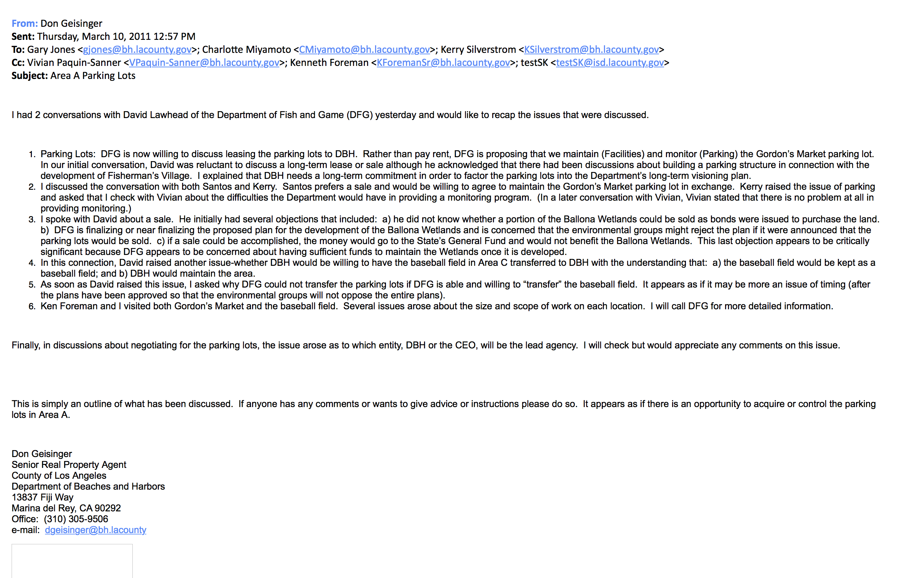

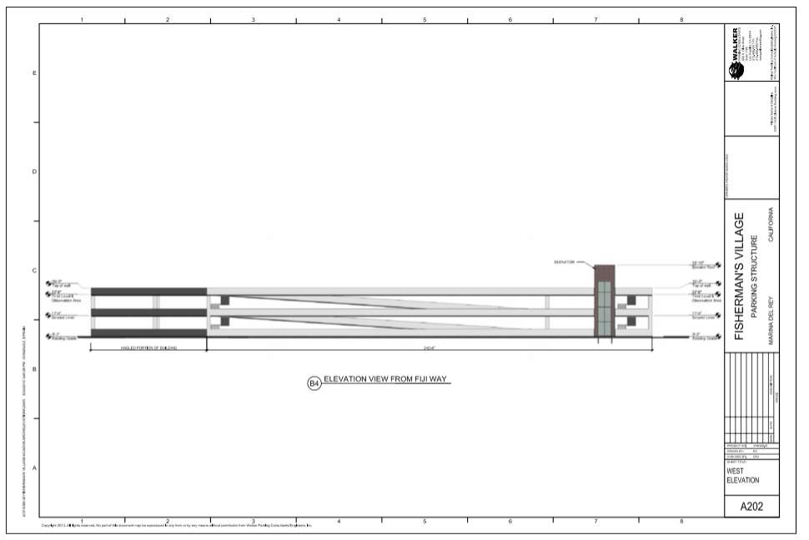

In Conclusion,
GC requests meeting to vet the CDP issues. There is urgency in meeting and addressing the CCC history and CDP(s) influence upon Ballona’s restoration. It is necessary to to resolve the Playa Vista CDP(s) issues.

It is with great urgency that there is need to unravel what has occurred through time. The public’s interests are not served by an EIR/S that is highly flawed and without a concept alternative that embraces meaningfully, a seasonal freshwater ecosystem for Ballona Wetlands Ecological Reserve.
The CCC’s input for a BWER EIR/S would be ill-served and a waste of time and money if its historic characteristics—namely as a predominantly freshwater seasonal wetland are not provided as a viable alternative in any EIR/S.

Sincerely,
Patricia McPherson, Grassroots Coalition
310 397 5779

